[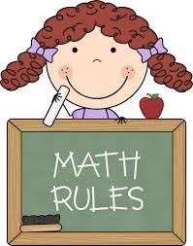](http://www.google.com/url?sa=i&rct=j&q=math+clip+art&source=images&cd=&cad=rja&uact=8&ved=0CAcQjRw&url=http://imgkid.com/math-clip-art-for-kids.shtml&ei=rQVJVKzUJ4qgyATcnIDQDw&bvm=bv.77880786,d.aWw&psig=AFQjCNFwtqWn2YXjJgffC2b1xlLL8akwDg&ust=1414158083873331)

Counting on is one of the first strategies that many students use for addition. The “**counting on**” strategy encourages students to begin with the largest number in the equation and count up by ones. For example, in the equation 5+3, the student should start at “5” and count up “6, 7, 8” to get the sum of the two numbers.

It is important to note that counting on is an efficient beginning strategy when adding 1,2,3 or 4 to a number. When adding larger numbers, for example, 6+7, counting on becomes less efficient as it is easier for students to get mixed up and lose track while counting.

As we move into finding the “unknown” parts of equations, please encourage your child to use this counting on strategy to help efficiently solve the problem!